**UFOS**

Using JavaScript, bootstrap to make a UFO sightings page

**Overview of the Project**

For this project we are building an HTML page that will allow us to pull up information from a java script data file using filters on the page. We want to use filters since we have many different sightings that occurred throughout the U.S.-- based on the different areas or what type of shape of the sighting.

**HTML Page and our results**

[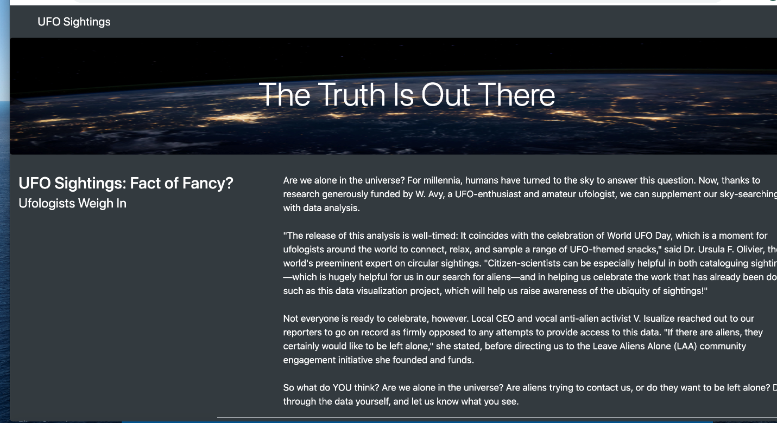](https://user-images.githubusercontent.com/67278193/94994945-de585280-0568-11eb-836d-0c2a02e839c9.png)

Once entering the website our client will see the basic opening and title with the picture at the top, as the client scrolls down they will begin to see all the data and filters that we have (which is in the image below). From this image below we have 5 different filters to choose from: the date, city, state, country & shape. You can choose any of these filters enter the search bar, then the HTML page will show all of the sightings for that specific search. Multiple filters can be entered at the same time to further inspect the data in the specific search bar that is entered.

[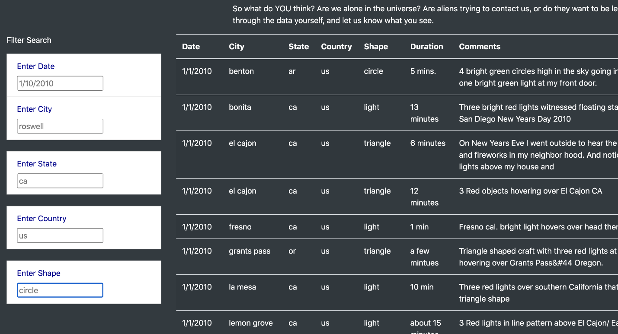](https://user-images.githubusercontent.com/67278193/94994943-dbf5f880-0568-11eb-8740-9c614604bd8a.png)

**Summary**

We have created a page that looks clean and allows the user to filter through the different settings in our data set using the search bars created. One big drawback about our search bar is trying to validate the settings that happened which can be better described in the data. If we had how many people were at the siting would be a helpful element to validating the claims. Having as much data as possible for website would make it as good as it can possible be. My two recommendations for improving this website would 1. to have more data that has more information including how many people were at the site 2. adding another filter to find the settings by length and last but not least have a site that would be constantly updating our data adding new settings to our page.